“Senza Riflesso”
A ShortFilm by Asia Borioli
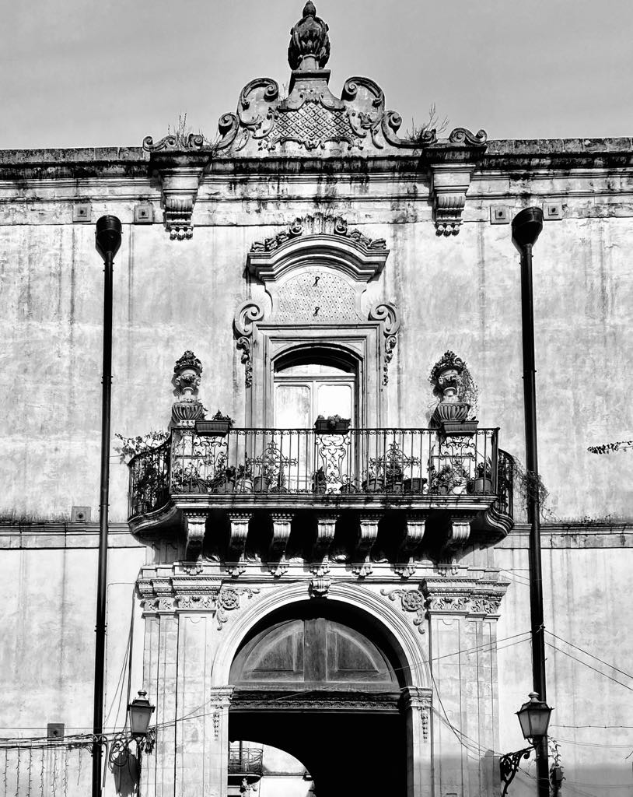
Director Asia Borioli
Help Directed Michele Iocolano
Soundtrack Michele Iocolano
With Antonella Leotta and Alessandro Romano
nocountryforoldmen@gmail.com

Synopsis
Nora is an opera singer who, upset by some events in her life, decides to take refuge on an island. The only encounter she will have will be with a fisherman who brings her groceries from the mainland. In her solitude, Nora will no longer be aware of herself or the events that will which bring her into a confused state.

Director's notes
The subject was conceived as a reflection on the human mind and on the artistic choices of the authors themselves who, trying to observe themselves, reflect their fears in the darkness of the main character, Nora, played by Antonella Leotta. The figure of the fisherman, Nora's only contact with reality, will be interpreted by Alessandro Romano.
The short film will take place almost entirely in the "home" of the protagonist and in "her" garden. It will be the evolution of a combination of different experiences that will focus on a common goal: to reflect the darkness present in ourselves.

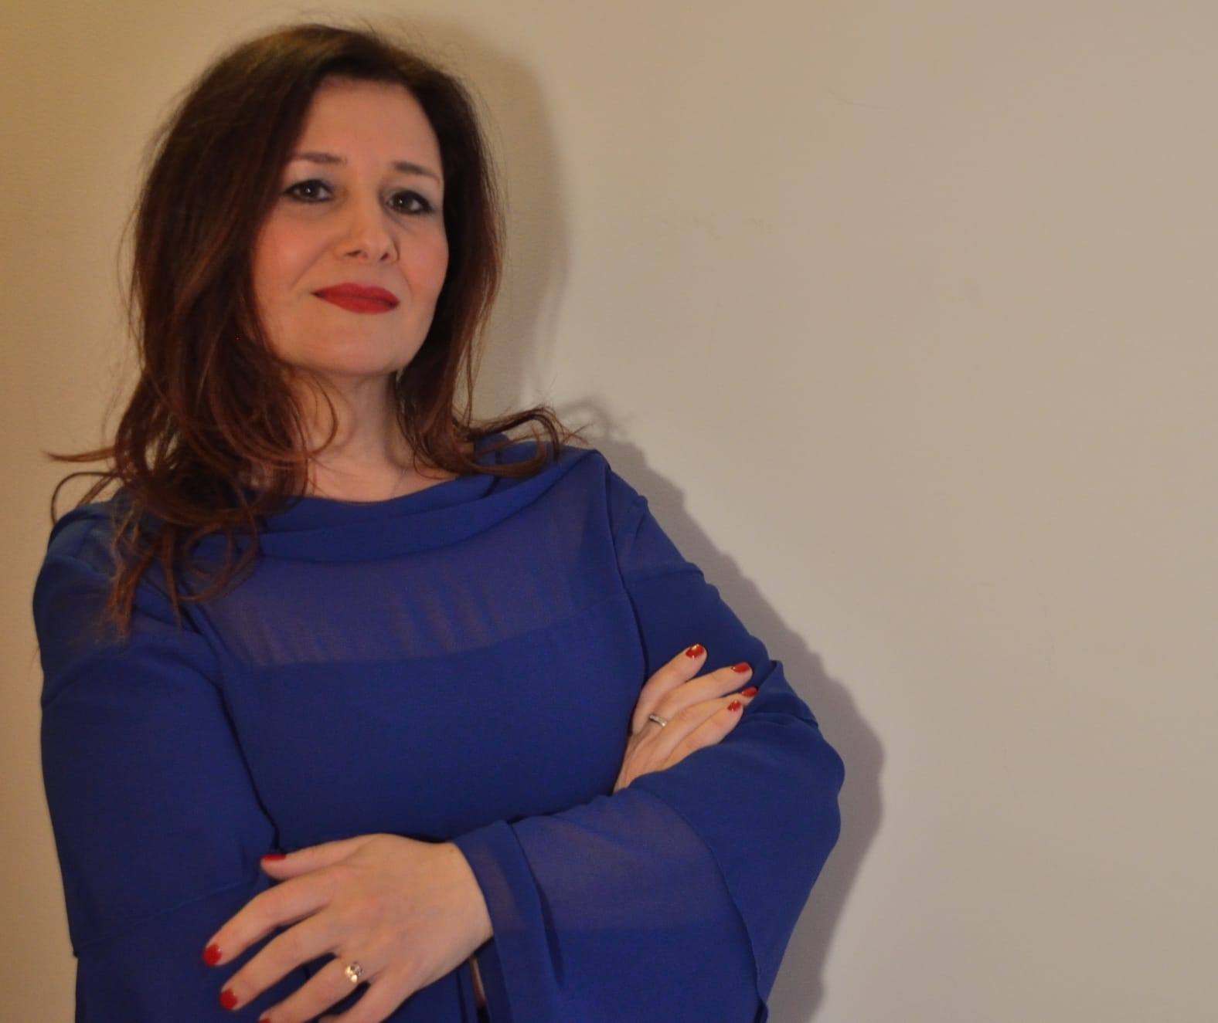

Antonella Leotta
· Jazz singer, Opera, Choral and Didatta. Vocal Power Singing Method instructor by Elisabeth Howard Lyric singing diploma Winner of the Massimo Urbani award
BIOGRAPHY
His musical training began with jazz and concert activity, but he soon devoted himself to classical studies, graduating in opera singing. He improved with the Mezzosoprano Biancamaria Casoni at the Music School of Milan. He is a stable and soloist artist at the "Sicilian Choir" often toured abroad in prestigious Opera and opera festivals such as Macau, Tianjin and Harbin, Canton as well as in Italy (RaRo festival in Arezzo) , the Theaters of Taormina, Siracusa and Tindari.
He collaborates as Artist of the Seasonal Choir at the Bellini Theater in Catania.
He attended several opera singing seminars: with the tenor Filippo Piccolo, the mezzo-soprano Carmen Gonzales and the soprano Giovanna Collica.
He has performed several concerts of sacred music as a soloist including the "Stabat Mater" by G.B. Pergolesi, Requiem "by W.A. Mozart, the "Magnificat" by J.S. Bach, the "Mass of the Coronation" by W.A. Mozart, the "Gloria" by A. Vivaldi and the "Via Crucis" by Listz.
She performed in concert proposing arias and duets of chamber music, Liederistica and Opera.
At the "Spazio Musica" association in Orvieto directed by Gabriella Ravazzi, she participated in the staging of "Il matrimonio segreto" by D. Cimarosa in the role of Fidalma.
Multiple experiences in the jazz field.
Massimo Urbani (P.I.M.U.) wins the Jazz Contest in the voices category; also Stefano Bollani on the jury. Here it is called a singer with an exquisitely jazzy vocalism, accompanied by a timbre of unusual beauty. He has three records: The sound of the beat "with Antonio Ferlito and Massimo Faraò," Swing to the moon "with" the Acappella Swingers "and" First "as lead vocalist of the Orchestra Jazz del Mediterraneo (OJM) featuring Pietro Tonolo. With "O.J.M" he also collaborated with important jazz figures such as Bob Mintzer and Gianni Basso. Vocal Groups of which he was a member: "The Acappella Swingers", "Quintessence" and "Vocal Vocation". A project of original pieces is in preparation. His latest project is "A new realese" in which, after careful consideration of vocality in the jazz tradition, he revisits compositions from the past and recent. He attended seminars and masterclasses with F. D ’Andrea, S. Jordan, Bob Mintzer, Luca Jurman, Elisa Turlà, Bob Stoloff, Joey Blake and Barbara Casini.
For several years he has been actively participating as a singer in musical shows.
He carries out educational activities at various musical facilities, where he teaches classical singing and jazz. She is also an instructor of the "Vocal Power" method by Elisabeth Howard.

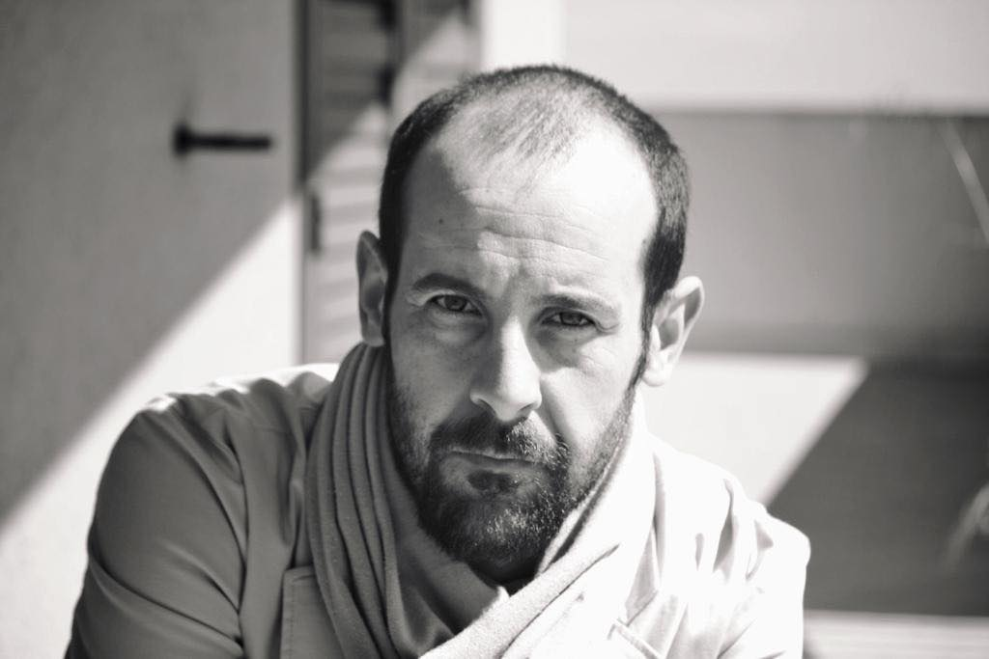

Alessandro Romano
Actor and Director
Candidate for the Press Award
as Best Young Actor

Biography
Alessandro Romano, Actor and Director, graduated from the Pietro Sharoff Academy of Dramatic Arts in Rome in 2002. He was involved in important theatrical productions performed in Italy and abroad by Teatro di Roma, Teatro Stabile di Catania, dell 'National Institute of Ancient Drama and Teatro Biondo Stabile of Palermo. In his theatrical career he has worked among others with Vincenzo Pirrotta, Ninni Bruschetta, Michele Abbondanza, Giancarlo Sepe, Daniele Salvo, Luigi lo Cascio, Anna Bonajuto, Giorgio Albertazzi, Elisabetta Pozzi, Andrea Giordana, Ugo Pagliai, Luca De Fusco, Mario Scaccia , Roberto Guicciardini. He has acted in shows of great national success such as "TERRA MATTA", "THE FESTIVAL OF THE LORD OF THE SHIP", "U CICLUPU", "COEFORE", "EDIPO RE", "DICERIA DELL'UNNO". In 2013 he was nominated for the Press Award for Best Young Actor in Classical performances in Syracuse, for the show Women in Parliament. As a director he directed the shows The reason of a dream, Mamma Fausa, The Family of Nettles, Like a cloud in trousers, Mal Bianco, Near a large garden with which he represented Italy in Bucharest at the Italian Cultural Institute .

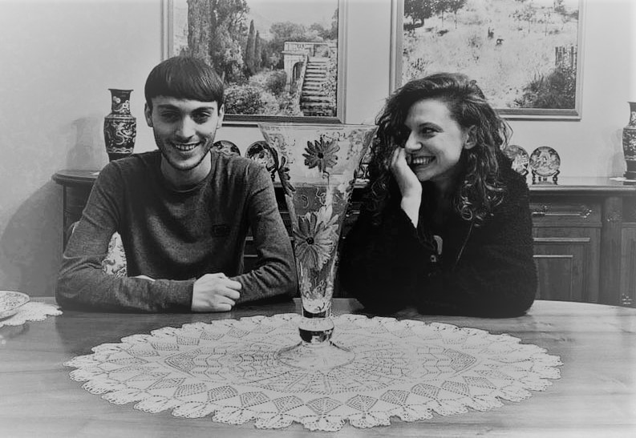
Michele Iocolano and Asia Borioli
Composer and Director
Winners at the LiftOffSession 2019 round-social
FirstTimeFilmMaker Session 2019 candidates

Biography
Asia Borioli and Michele Iocolano have been working together for a year. They deal with Screenplay, composition of Soundtracks and Direction.
Music videos: Odyssey, White Angel, Leave The Soul (in progress), Winter Sunrise (in progress) Nebula (in progress).
Short films: The Dance Of Death, Welcome, Enverom, Come On (in progress).
Documentaries: Winter Oil (in progress).

